JUnit Testing Exercises

**Exercise 1: Setting Up JUnit**

Scenario:

You need to set up JUnit in your Java project to start writing unit tests.

**pom.xml:**

<project xmlns="http://maven.apache.org/POM/4.0.0"

xmlns:xsi="http://www.w3.org/2001/XMLSchema-instance"

xsi:schemaLocation="http://maven.apache.org/POM/4.0.0

http://maven.apache.org/xsd/maven-4.0.0.xsd">

<modelVersion>4.0.0</modelVersion>

<groupId>com.example</groupId>

<artifactId>junitdemo</artifactId>

<version>1.0-SNAPSHOT</version>

<dependencies>

<dependency>

<groupId>junit</groupId>

<artifactId>junit</artifactId>

<version>4.13.2</version>

<scope>test</scope>

</dependency>

</dependencies>

<build>

<plugins>

<plugin>

<groupId>org.apache.maven.plugins</groupId>

<artifactId>maven-compiler-plugin</artifactId>

<version>3.8.1</version>

<configuration>

<source>11</source>

<target>11</target>

</configuration>

</plugin>

</plugins>

</build>

</project>

**GreetingService.java**

package com.example;

public class GreetingService

{

public String greet(String name)

{

if (name == null || name.trim().isEmpty())

{

return "Hello, stranger!";

}

return "Hello, " + name + "!";

}

}

**GreetingServiceTest.java**

package com.example;

import org.junit.Test;

import static org.junit.Assert.*;

public class GreetingServiceTest

{

@Test

public void testGreetWithName()

{

GreetingService service = new GreetingService();

String result = service.greet("Reshma");

assertEquals("Hello, Reshma!", result);

}

@Test

public void testGreetWithEmpty()

{

GreetingService service = new GreetingService();

String result = service.greet("");

assertEquals("Hello, stranger!", result);

}

@Test

public void testGreetWithNull()

{

GreetingService service = new GreetingService();

String result = service.greet(null);

assertEquals("Hello, stranger!", result);

}

}

**Result:**

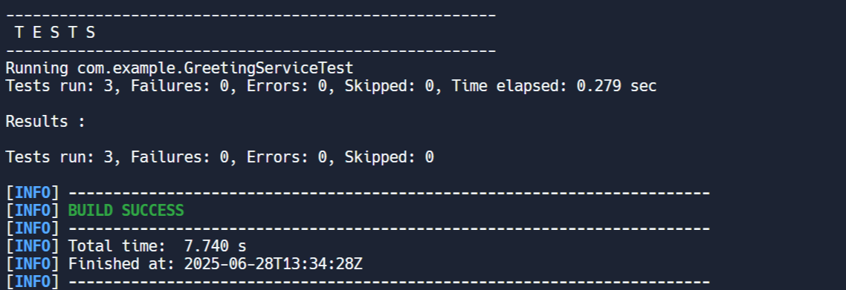

**Exercise 3: Assertions in JUnit**

Scenario:

You need to use different assertions in JUnit to validate your test results

**Pom.xml:**

<project xmlns="http://maven.apache.org/POM/4.0.0"

xmlns:xsi="http://www.w3.org/2001/XMLSchema-instance"

xsi:schemaLocation="http://maven.apache.org/POM/4.0.0

https://maven.apache.org/xsd/maven-4.0.0.xsd">

<modelVersion>4.0.0</modelVersion>

<groupId>com.example</groupId>

<artifactId>junit-demo</artifactId>

<version>1.0-SNAPSHOT</version>

<properties>

<maven.compiler.source>11</maven.compiler.source>

<maven.compiler.target>11</maven.compiler.target>

</properties>

<dependencies>

<dependency>

<groupId>junit</groupId>

<artifactId>junit</artifactId>

<version>4.13.2</version>

<scope>test</scope>

</dependency>

</dependencies>

<build>

<plugins>

<plugin>

<groupId>org.apache.maven.plugins</groupId>

<artifactId>maven-compiler-plugin</artifactId>

<version>3.8.1</version>

<configuration>

<source>11</source>

<target>11</target>

</configuration>

</plugin>

</plugins>

</build>

</project>

**AssertionsTest.java:**

package com.example;

import org.junit.Test;

import static org.junit.Assert.*;

public class AssertionsTest

{

@Test

public void testAssertions()

{

assertEquals(5, 2 + 3);

assertTrue(5 > 3);

assertFalse(5 < 3);

assertNull(null);

assertNotNull(new Object());

}

}

**Result:**

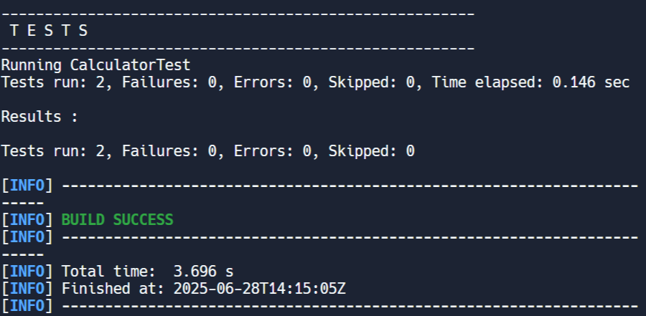

**Exercise 4: Arrange-Act-Assert (AAA) Pattern, Test Fixtures, Setup and Teardown Methods in JUnit**

Scenario:

You need to organize your tests using the Arrange-Act-Assert (AAA) pattern and use setup

and teardown methods.

**Pom.xml:**

<project xmlns="http://maven.apache.org/POM/4.0.0"

xmlns:xsi="http://www.w3.org/2001/XMLSchema-instance"

xsi:schemaLocation="http://maven.apache.org/POM/4.0.0

https://maven.apache.org/xsd/maven-4.0.0.xsd">

<modelVersion>4.0.0</modelVersion>

<groupId>com.example</groupId>

<artifactId>junit-demo</artifactId>

<version>1.0-SNAPSHOT</version>

<properties>

<maven.compiler.source>11</maven.compiler.source>

<maven.compiler.target>11</maven.compiler.target>

</properties>

<dependencies>

<dependency>

<groupId>junit</groupId>

<artifactId>junit</artifactId>

<version>4.13.2</version>

<scope>test</scope>

</dependency>

</dependencies>

</project>

**CalculatorTest.java**

package com.example;

import org.junit.Before;

import org.junit.After;

import org.junit.Test;

import static org.junit.Assert.*;

public class CalculatorTest

{

private Calculator calculator;

@Before

public void setUp()

{

calculator = new Calculator();

System.out.println("Setup completed.");

}

@After

public void tearDown()

{

System.out.println("Test completed.\n");

}

@Test

public void testAddition()

{

int a = 10, b = 20;

int result = calculator.add(a, b);

assertEquals(30, result);

}

@Test

public void testMultiplication()

{

int a = 5, b = 4;

int result = calculator.multiply(a, b);

assertEquals(20, result);

}

}

**Calculator.java**

package com.example;

public class Calculator

{

public int add(int a, int b)

{

return a + b;

}

public int multiply(int a, int b)

{

return a * b;

}

}

**Result:**

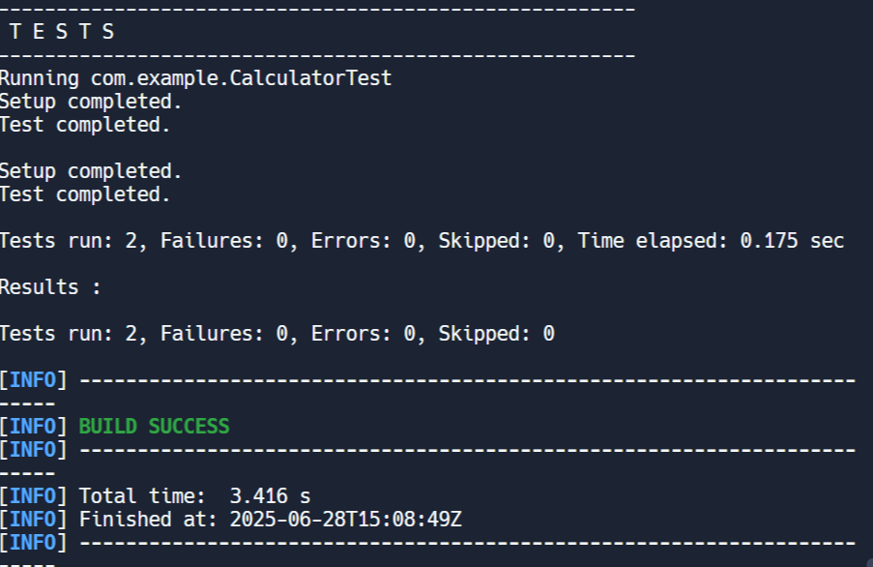

Mockito Hands-On Exercises

**Exercise 1: Mocking and Stubbing**

Scenario:

You need to test a service that depends on an external API. Use Mockito to mock the external API and stub its methods.

**Pom.xml:**

<project xmlns="http://maven.apache.org/POM/4.0.0"

xmlns:xsi="http://www.w3.org/2001/XMLSchema-instance"

xsi:schemaLocation="http://maven.apache.org/POM/4.0.0

http://maven.apache.org/xsd/maven-4.0.0.xsd">

<modelVersion>4.0.0</modelVersion>

<groupId>com.example</groupId>

<artifactId>mockito-example</artifactId>

<version>1.0-SNAPSHOT</version>

<properties>

<maven.compiler.source>11</maven.compiler.source>

<maven.compiler.target>11</maven.compiler.target>

</properties>

<dependencies>

<dependency>

<groupId>org.junit.jupiter</groupId>

<artifactId>junit-jupiter</artifactId>

<version>5.9.3</version>

<scope>test</scope>

</dependency>

<dependency>

<groupId>org.mockito</groupId>

<artifactId>mockito-core</artifactId>

<version>5.11.0</version>

<scope>test</scope>

</dependency>

</dependencies>

<build>

<plugins>

<plugin>

<groupId>org.apache.maven.plugins</groupId>

<artifactId>maven-surefire-plugin</artifactId>

<version>3.0.0-M5</version>

</plugin>

</plugins>

</build>

</project>

**ExternalApi.java**

public interface ExternalApi

{

String getData();

}

**MyServiceTest.java**

import org.junit.jupiter.api.Test;

import org.mockito.Mockito;

import static org.mockito.Mockito.*;

import static org.junit.jupiter.api.Assertions.*;

public class MyServiceTest

{

@Test

public void testFetchDataReturnsMockedValue()

{

ExternalApi mockApi = Mockito.mock(ExternalApi.class);

when(mockApi.getData()).thenReturn("Mocked API Response");

MyService service = new MyService(mockApi);

String result = service.fetchData();

assertEquals("Mocked API Response", result);

}

}

**MyService.java**

public class MyService

{

private ExternalApi api;

public MyService(ExternalApi api)

{

this.api = api;

}

public String fetchData()

{

return api.getData();

}

}

**Result:**

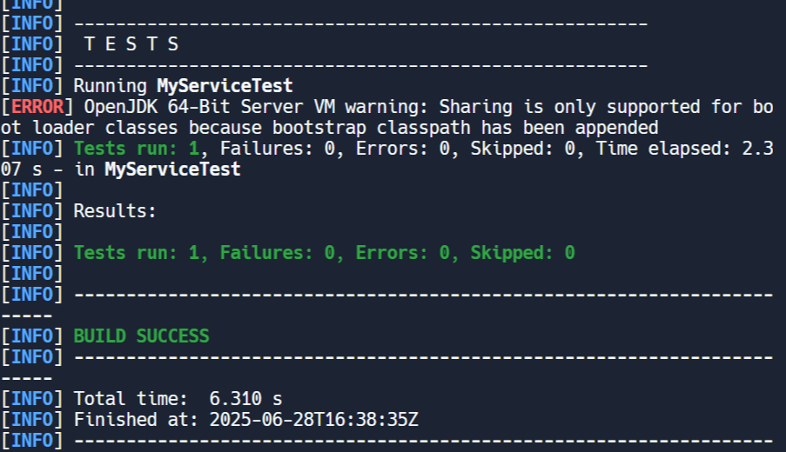

**Exercise 2: Verifying Interactions**

Scenario:

You need to ensure that a method is called with specific arguments.

**Pom.xml:**

<project xmlns="http://maven.apache.org/POM/4.0.0"

xmlns:xsi="http://www.w3.org/2001/XMLSchema-instance"

xsi:schemaLocation="http://maven.apache.org/POM/4.0.0

http://maven.apache.org/xsd/maven-4.0.0.xsd">

<modelVersion>4.0.0</modelVersion>

<groupId>com.example</groupId>

<artifactId>mockito-test</artifactId>

<version>1.0-SNAPSHOT</version>

<properties>

<maven.compiler.source>11</maven.compiler.source>

<maven.compiler.target>11</maven.compiler.target>

</properties>

<dependencies>

<dependency>

<groupId>org.junit.jupiter</groupId>

<artifactId>junit-jupiter</artifactId>

<version>5.9.3</version>

<scope>test</scope>

</dependency>

<dependency>

<groupId>org.mockito</groupId>

<artifactId>mockito-core</artifactId>

<version>5.11.0</version>

<scope>test</scope>

</dependency>

</dependencies>

<build>

<plugins>

<plugin>

<groupId>org.apache.maven.plugins</groupId>

<artifactId>maven-surefire-plugin</artifactId>

<version>3.0.0-M5</version>

</plugin>

</plugins>

</build>

</project>

**ExternalApi.java**

public interface ExternalApi

{

String getData();

}

**MyService.java**

public class MyService

{

private ExternalApi api;

public MyService(ExternalApi api)

{

this.api = api;

}

public String fetchData()

{

return api.getData();

}

}

**MyServiceTest.java**

import static org.mockito.Mockito.*;

import org.junit.jupiter.api.Test;

import org.mockito.Mockito;

public class MyServiceTest

{

@Test

public void testVerifyInteraction()

{

ExternalApi mockApi = Mockito.mock(ExternalApi.class);

MyService service = new MyService(mockApi);

service.fetchData();

verify(mockApi).getData();

}

}

**Result:**

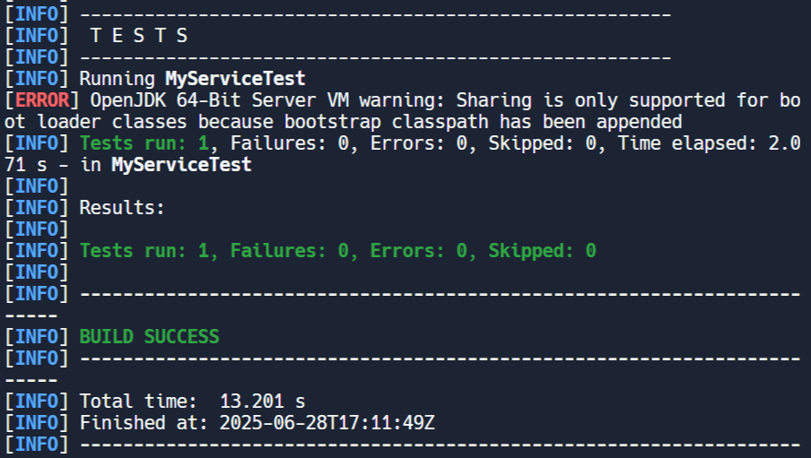

Logging using SLF4J

**Exercise 1: Logging Error Messages and Warning Levels**

Task: Write a Java application that demonstrates logging error messages and warning levels using SLF4J.

**pom.xml:**

<project xmlns="http://maven.apache.org/POM/4.0.0"

xmlns:xsi="http://www.w3.org/2001/XMLSchema-instance"

xsi:schemaLocation="http://maven.apache.org/POM/4.0.0

http://maven.apache.org/xsd/maven-4.0.0.xsd">

<modelVersion>4.0.0</modelVersion>

<groupId>com.example</groupId>

<artifactId>logging-demo</artifactId>

<version>1.0-SNAPSHOT</version>

<properties>

<maven.compiler.source>1.8</maven.compiler.source>

<maven.compiler.target>1.8</maven.compiler.target>

</properties>

<dependencies>

<dependency>

<groupId>org.slf4j</groupId>

<artifactId>slf4j-api</artifactId>

<version>1.7.30</version>

</dependency>

<dependency>

<groupId>ch.qos.logback</groupId>

<artifactId>logback-classic</artifactId>

<version>1.2.3</version>

</dependency>

</dependencies>

<build>

<plugins>

<plugin>

<groupId>org.apache.maven.plugins</groupId>

<artifactId>maven-compiler-plugin</artifactId>

<version>3.8.1</version>

<configuration>

<source>1.8</source>

<target>1.8</target>

</configuration>

</plugin>

<plugin>

<groupId>org.codehaus.mojo</groupId>

<artifactId>exec-maven-plugin</artifactId>

<version>3.0.0</version>

</plugin>

</plugins>

</build>

</project>

**logback.xml**

<configuration>

<appender name="STDOUT" class="ch.qos.logback.core.ConsoleAppender">

<encoder>

<pattern>%d{HH:mm:ss.SSS} [%thread] %-5level %logger{36} - %msg%n</pattern>

</encoder>

</appender>

<root level="debug">

<appender-ref ref="STDOUT"/>

</root>

</configuration>

**LoggingExample.java**

import org.slf4j.Logger;

import org.slf4j.LoggerFactory;

public class LoggingExample

{

private static final Logger logger = LoggerFactory.getLogger(LoggingExample.class);

public static void main(String[] args)

{

logger.error("This is an error message");

logger.warn("This is a warning message");

}

}

**Result:**

